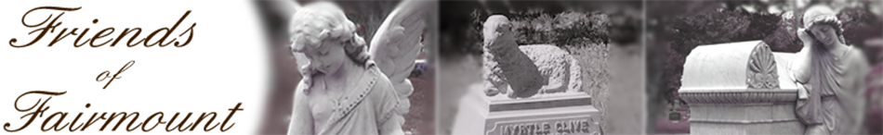

Are you interested in volunteering for an exciting 5th grade education program sponsored by the Friends of Fairmount? It’s called Stones and Bones: Where History is Buried.

This 2-day program is designed to familiarize our students with local history and the famous citizens of San Angelo who rest at Fairmount Cemetery. History will come alive!

Students will get an overview of the history of the cemetery on day one at school. The next day we will go to Fairmont Cemetery for Field Day Activities to visit some of the historical folks and facts featured in the classroom presentation. This year the Friends of Fairmont need volunteers to help with the Field Day activities. Activities include a Famous Folks Scavenger Hunt, Photo Safari and Headstone Rubbings.

**The Field Day is TBA for each school. The student activities will begin at appx 9AM and conclude with lunch at the cemetery**. *(Students will be bused from campus and volunteers will need to meet at the cemetery by 8:45 for orientation & check-in)*

**If you would like to volunteer and be part of this project, please fill out the information below.**

----------------------------------------------------------------------------------------------------

Cut and Return Form to Student’s Teacher



**Stones & Bones:**

**Where History is Buried**

____ I can help with the Field Day

***Thank You!***

_______________________________ ______________________________

Name (PRINT) Signature

______________________________ ______________________________

Phone # e-mail address